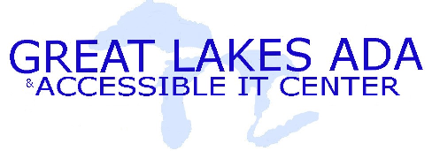 | Fact Sheet: Electronic Text Resources
(800) 949-4232
www.adagreatlakes.org

Federal Legislation

Chafee Amendment
(http://www.loc.gov/nls/reference/factsheets/copyright.html) Specifically provides an exception to the standard requirement that all users of copyright-protected works obtain permission prior to reproducing or distributing the work. The Chafee Amendment specifies that it is not a violation of the Copyright Act for authorized non-profit agencies to reproduce or distribute copyright-protected works for persons with certain specific verifiable disabilities.

Section 504 of the Rehabilitation Act
(http://www.section508.gov/index.cfm?FuseAction=Content&ID=15)
Requires that recipients of Federal funding make adjustments to programs as necessary to afford individuals with disabilities "an equal opportunity to obtain the same result, to gain the same benefit, or to reach the same level of achievement, in the most integrated setting appropriate to the person's needs."

Americans with Disabilities Act, Title II
(http://www.adagreatlakes.org/ADA/Default.asp?title=2)Requires that recipients of State funding make adjustments to programs as necessary to afford individuals with disabilities "an equal opportunity to obtain the same result, to gain the same benefit, or to reach the same level of achievement, in the most integrated setting appropriate to the person's needs."

National instructional Materials Accessibility Standard (NIMAS)
http://nimas.cast.org/about/index.html
A common file format, based off of XML-based DAISY, which provides electronic text formatting. NIMAS files are similar to HTML documents, but with special features and additions which allow for feature and content-rich volumes and books to be viewed or printed in the way that will best suit the user, as well as provide a consistent format for publishers for printing. NIMAS was passed as part of the Individuals with Disabilities Education Improvement Act of 2004 (IDEA).

Resources

BookShare
http://bookshare.org/
Created to save institutions time in converting text books into an electronic format by sharing previous work done by other schools

NIMAS @ CAST
http://nimas.cast.org/
Information about the NIMAS/DAISY file format and technical assistance.

