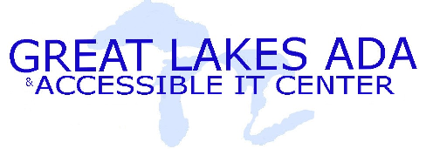 | Fact Sheet: Electronic Books: Why Go Digital?
(800) 949-4232
www.adagreatlakes.org

Electronic Books… Why go Digital?
From the American Library Association www.ala.org :
Considerations in Purchasing Accessible Library Materials
As librarians acquire materials for the library collections, consideration of accessibility issues should be at the forefront of the procurement process. The following is a short list of considerations and questions that librarians should ask:
- Are there accessible digital versions of the print materials available?
- Is there an accessible online version of the print materials?
- Is the print material available in large print?
- Will the publisher grant the library permission to transform the print material into an accessible digital format?
- For database and online services, is the service compatible with screen readers and does it offer non-visual access (command prompts)?
- For video materials, are there captioned and/or video described versions of the materials available for purchase?
- For digital materials, can you confirm that none of the text is embedded as graphics?
Electronic Book Solutions
Publisher | Web Address | Format
Publisher | Web Address | Computer  Software | Online  Materials | Alternative  Book Form
Attainment Company | www.attainmentcompany.com | 
EnableMart | www.enablemart.com | 
National Braille Press | www.nbp.org |  |  | 
Blackwell’s Book Service | www.blackwell.com |  |   
Don Johnston | www.donjohnston.com | 
Adobe |  |  | 
Thinking Reader | www.tomsnyder.com | 
Project Gutenberg | www.gutenberg.org |  | 
BookShare | www.bookshare.org |  | 

