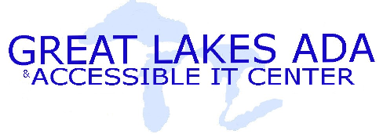 | Fact sheet: Questions to ask a Software Vendor

When purchasing or acquiring a new program or system, asking some basic questions about the system’s ability to support multiple ranges of abilities is an effective way to let a vendor know that you are looking for a product that will best support your users.

Software Checklist

Keyboard Access
- Is the application/system functional without a mouse?
- Can a user navigate the application by using traditional operators (such as the Tab Key)?
- Are shortcuts to important functionality provided within the system or application?

Sounds
- Are sounds the sole way of providing information (such as a warning or error indication)?
- Are visual cues available for sound events built into the application or system?
- Are there audio equivalents, such as captioning, available for any spoken text?
- Is there an option to adjust audio within the system or application?

Display
- Is color used in a way that it is the only way to convey information (such as warnings, status, etc.)?
- Are there sound cues available for visual alerts?

Validation
- Has the system been tested by people with different ranges of abilities and disabilities?
- Can the text within the application be accessed using alternative output devices?
- Has the system been tested with any assistive technologies?

Ask for References
Ask for references to other institutions that are currently using or evaluating their products. Peer-to-peer contacts can yield a great deal of information not available directly through a vendor, such as technical issues, accessibility, and unforeseen costs.
If you have any questions about this document, or would like any other assistance, please contact the Great Lakes ADA & IT Center at (800) 949-4232, or at http://www.adagreatlakes.org/

